Chapter 13, Problem 75.

A balanced three-phase transformer bank with the Δ-Y connection depicted in Fig. 13.136 below is used to step down line voltages from 4500 V rms to 900 V
rms. If the transformer feeds a 120-kVA load, find:

(a) the turns ratio for the transformer,

(b) the line currents at the primary and secondary sides.

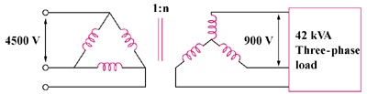

Figure 13.136
For Prob. 13.75.

